Visual Story for the Vale & Downland Museum

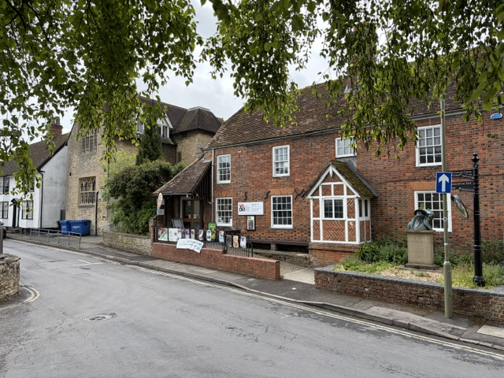
Welcome to the Vale and Downland Museum in Church Street, Wantage.

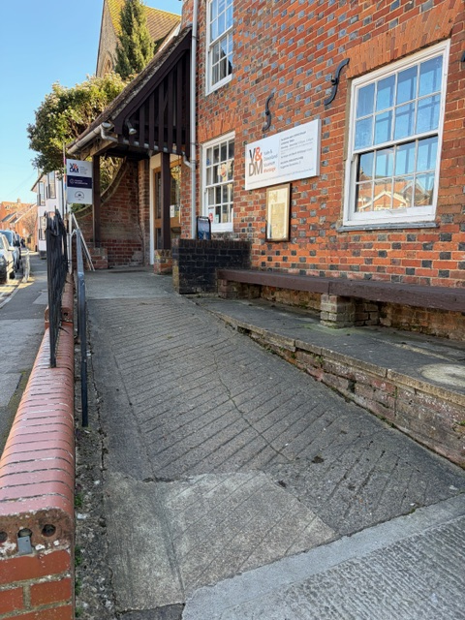
Here is the ramp to the front door of the museum.

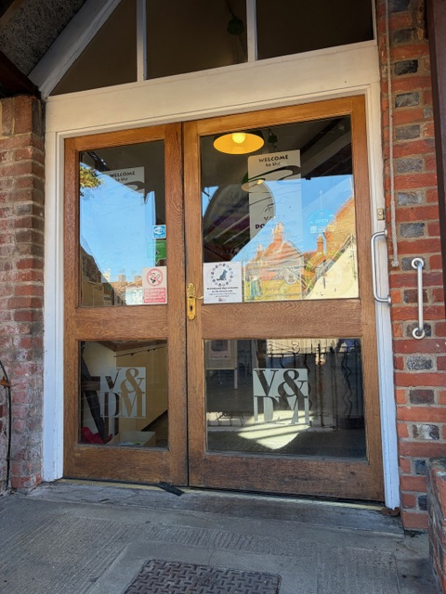

You will enter through the front door.

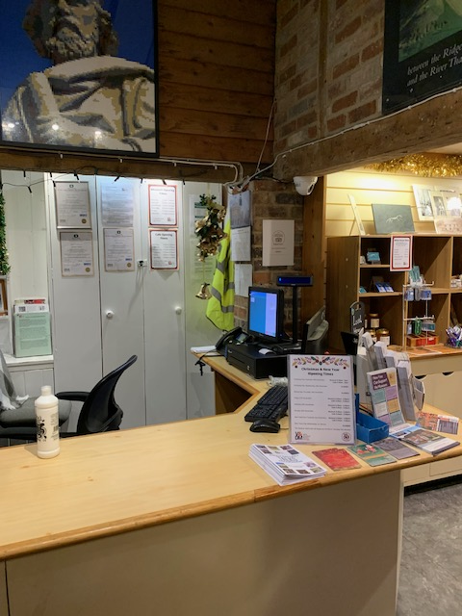
This is our reception desk.

You can ask here for information about the museum and the surrounding area.

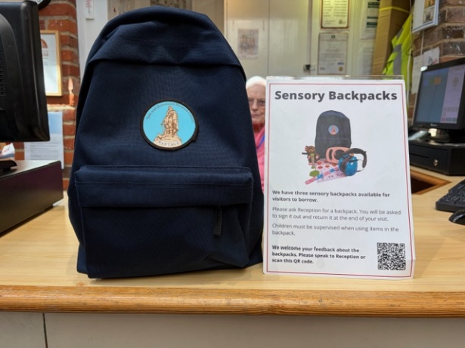

You can borrow a sensory backpack to use while you are in the museum.

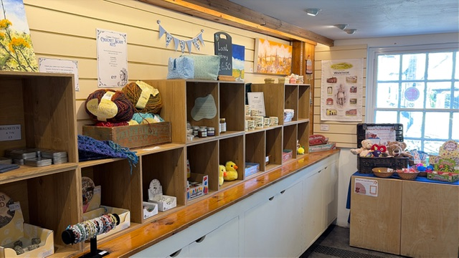

There is also a museum shop where you can buy things
This is the museum coffee shop.
You can buy something to eat or drink here.
Sometimes it is noisy if there are lots of people sitting at the tables.
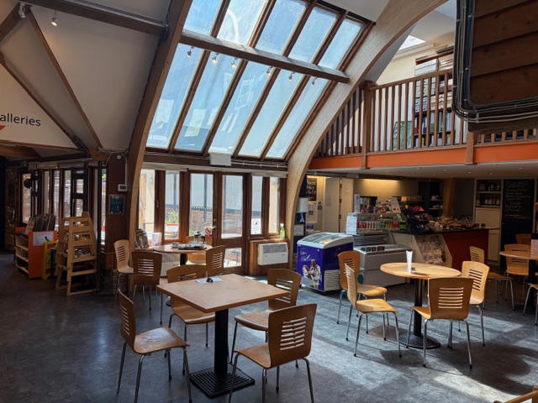

If you want somewhere quiet and the weather is nice, we have two outdoor terraces where you can sit.

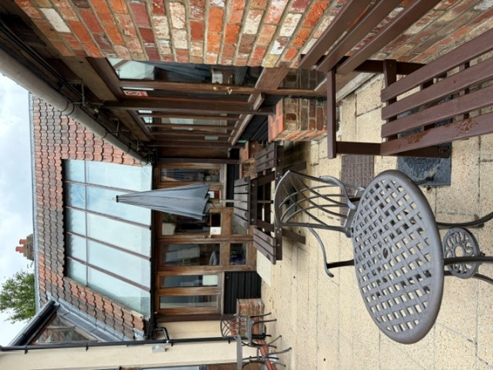
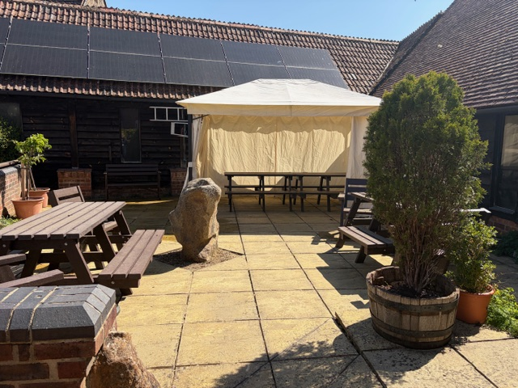

Here is the entrance to the museum galleries.

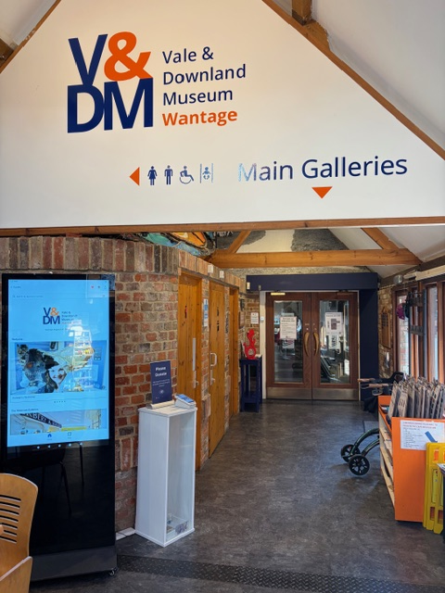

In this space, you can find free trail sheets.
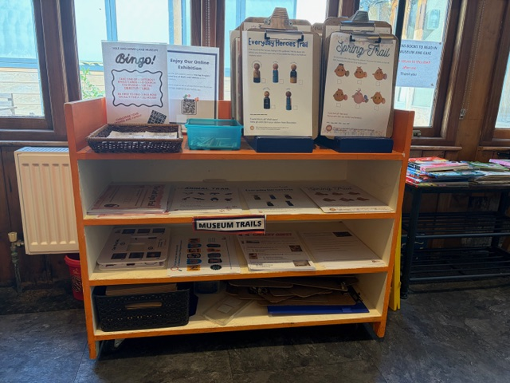
They show you things to look for as you go around the museum.

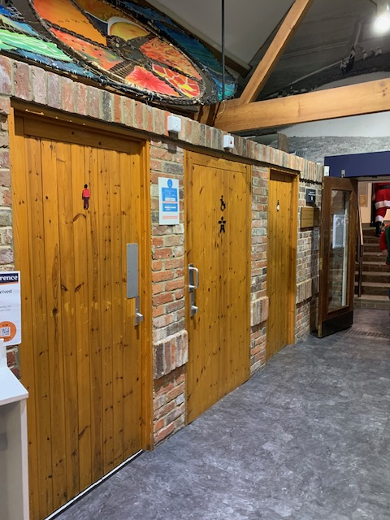

Our toilets are on the left, just before the door to the galleries.

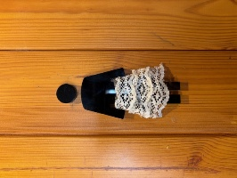
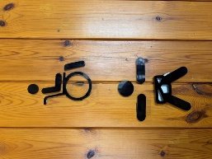
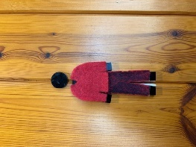

The hand driers are quite noisy but we have paper towels too.

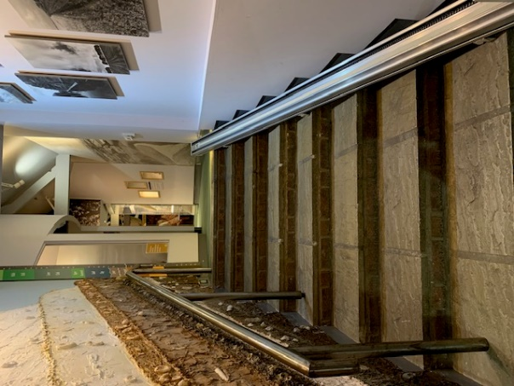
When you go through the door to the galleries, you will see some shallow stairs with a handrail.

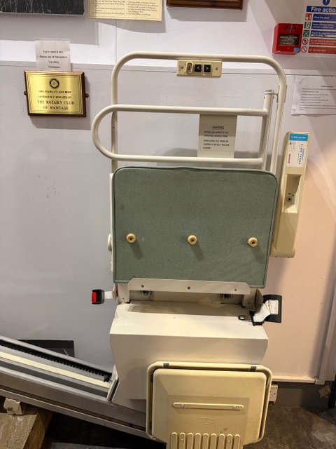
There is a stair lift.
Please ask at the reception desk if you want to use this and they will help you.

If you need a route with no stairs, there is one on the next page.
Way to the galleries with no stairs
Please ask the reception staff – they will show you the way and open all the doors for you.

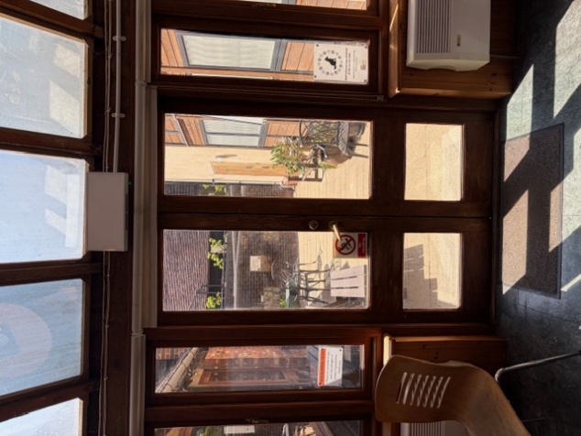

This door from the coffee shop will take you outside.

There is a ramp here that you can use.

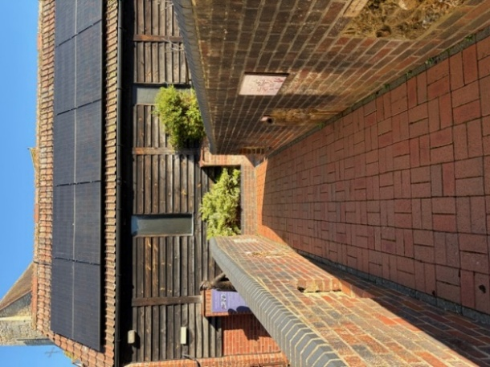
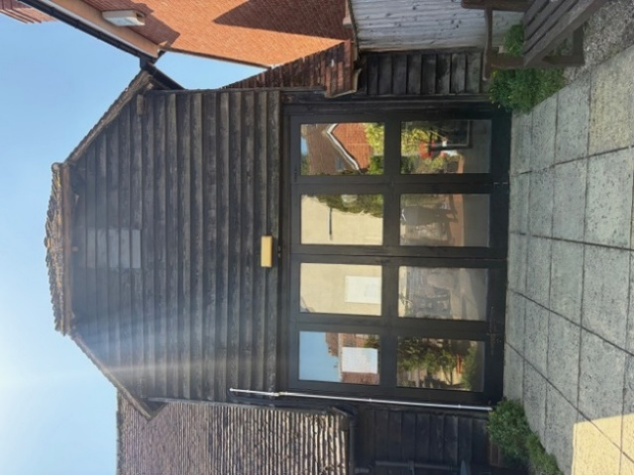
You will enter the galleries through this door.

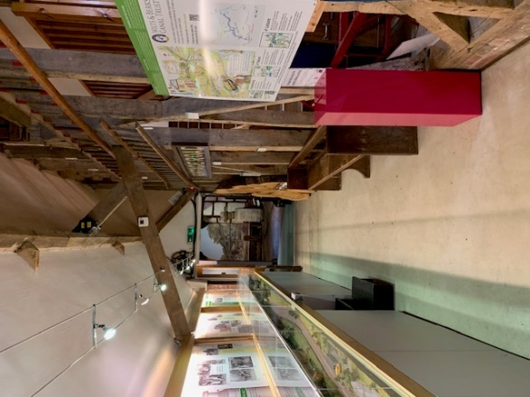

When you are inside, turn left and go past the model train.
…………………………………………………………………………………………………
Here is the Auditorium.
It is darker here.
You can press buttons to watch films about our area. Some of the films are quite loud!
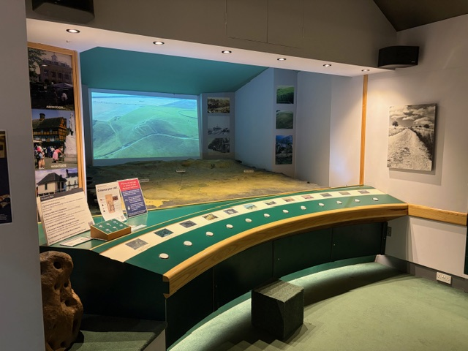
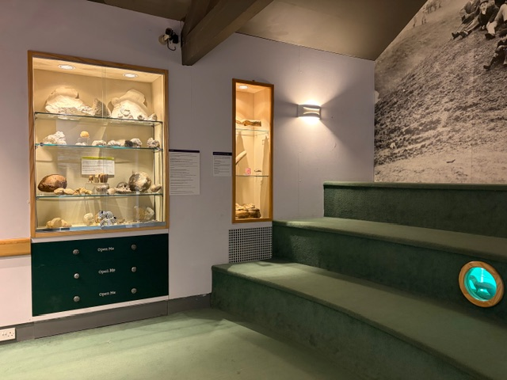

This is our New Arrivals Gallery. It is very light.
There is an Anglo-Saxon skeleton in a glass case.
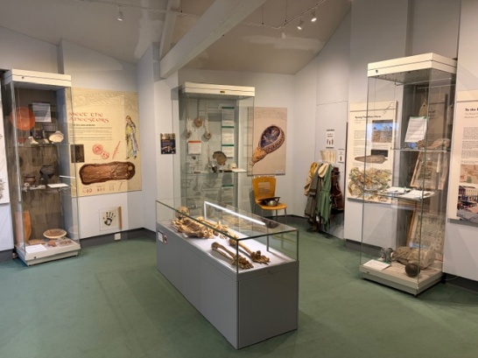

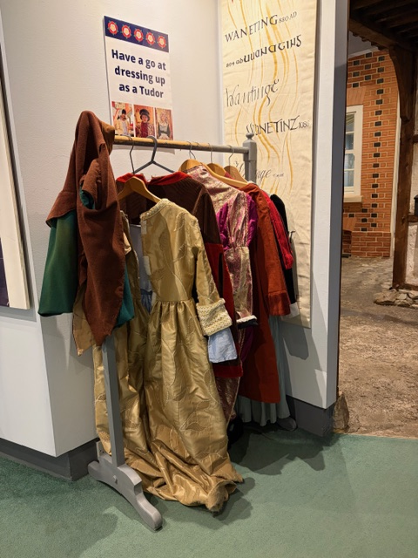
You may like to try dressing up.
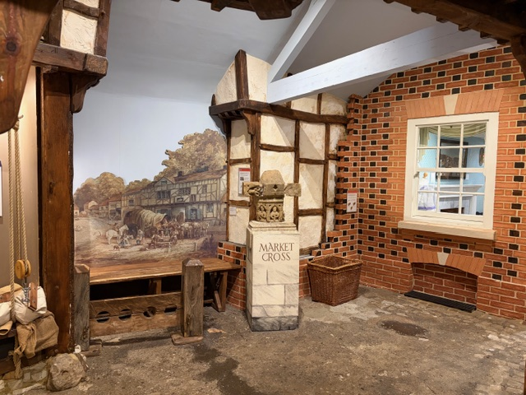

This is our Marketplace Gallery.

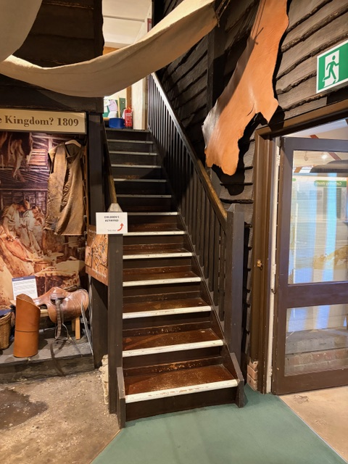
If you go up these stairs, you will find two more spaces with lots to do.

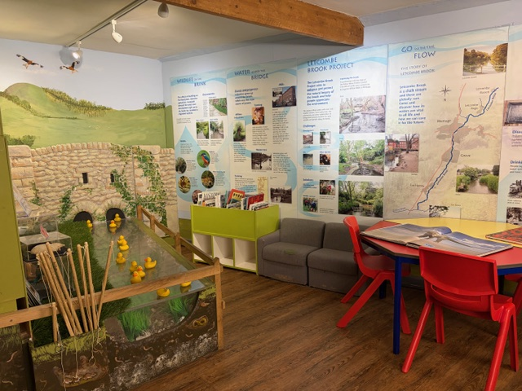

In this space, there are things you can do, such as books to read, colouring and Hook-a-Duck.

This is the King Alfred Gallery where you can learn about King Alfred and the Anglo-Saxons.
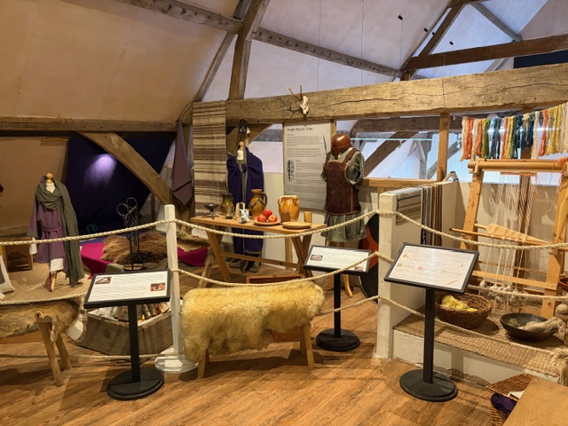
There is lots to see but please do not go past the ropes.

Back down the stairs, you can go through the other galleries…

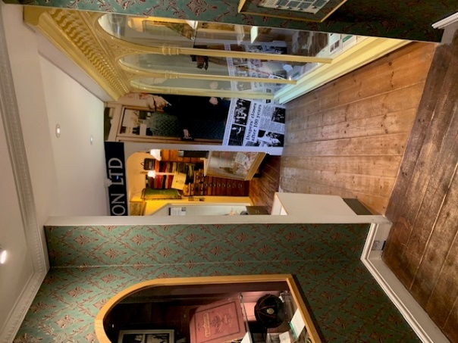
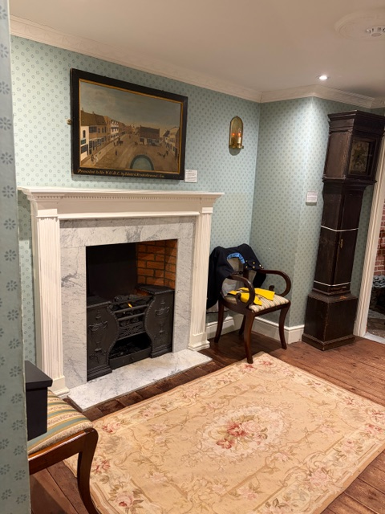

There are lots of objects in cases and on the walls.
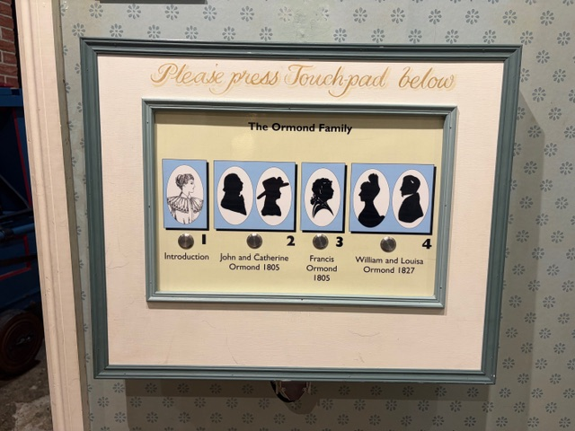
If you press these buttons, you will hear voices telling you about life in the past.

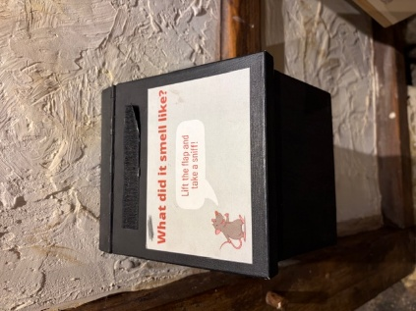

You may see these little boxes around the museum.
You can lift the lid to see what you can smell. Some of them are very smelly!

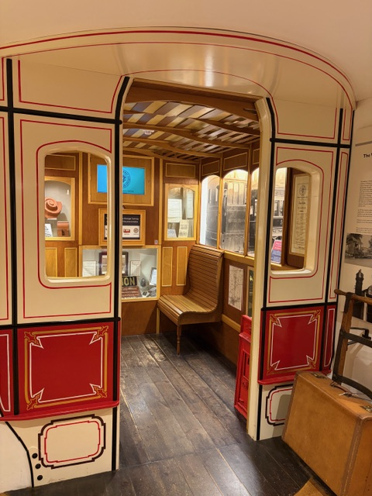

You can sit in an old tram carriage.

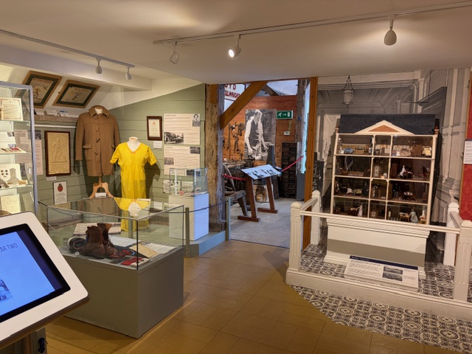
This is our Barn Gallery.
There are lots of objects to look at here too.

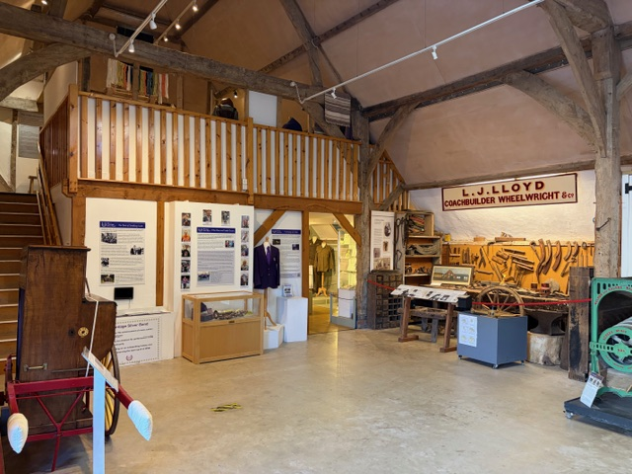
Sometimes there are craft workshops or talks in this space.

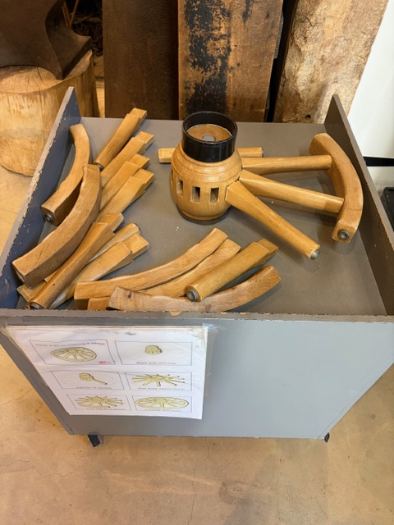
You can see if you can build a wheel.

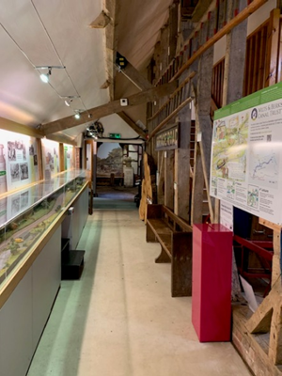
When you want to leave the Barn Gallery, go past the model train.

You can press the buttons to make the trains move.

Turn left to go back the same way you came in, down the stairs…
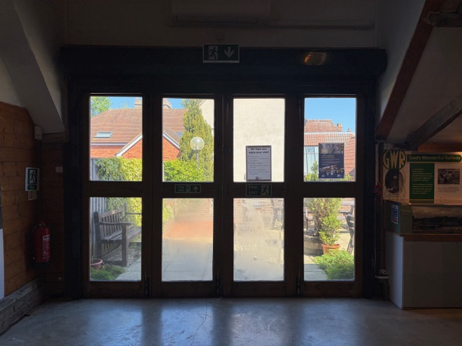
… or go out through the barn door if you are using the ramp.

Now you are back in the Coffee Shop.
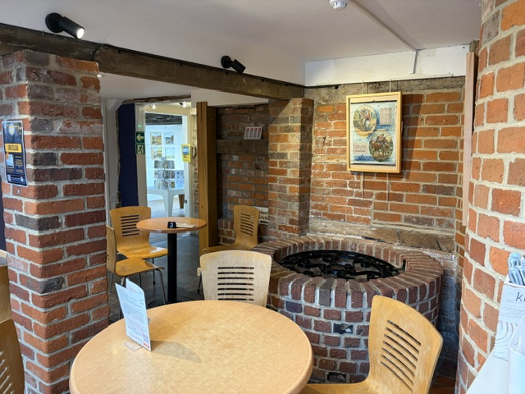

Behind the Coffee Shop is the Squires Room.
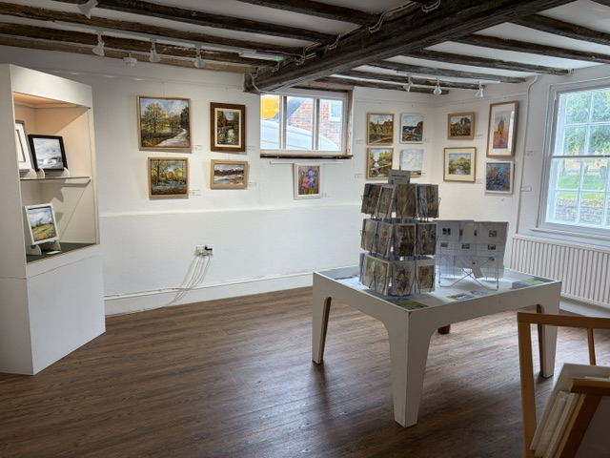
This is a room where we have special exhibitions.

There are sometimes craft activities or Lego sessions in this room.

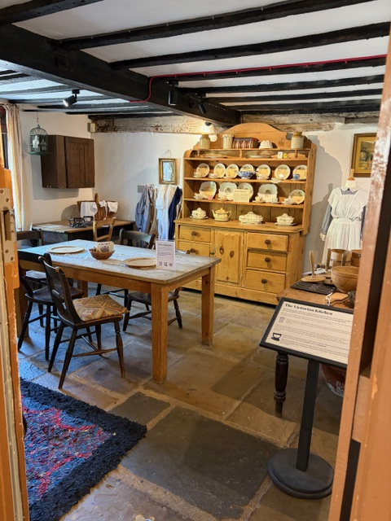
Opposite the Squires Room is the Victorian Kitchen.

If you are doing a trail, don’t forget to look in here!

We hope that you enjoy your visit to the museum. Please ask our staff if we can help you in any way.
……………………………………………………………………………………
Vale & Downland Museum,
19 Church St, Wantage, OX12 8BL.
Telephone: 01235 771447
Email:
info@valeanddownlandmuseum.org.uk
For School Visit enquiries:
learning@valeanddownlandmuseum.org.uk

Nearest car park
Portway car park, Wantage
Portway, Wantage, OX12 9BU
Charging hours
Monday to Saturday – 8am to 6pm
Sunday – free
If you display your Blue Badge, parking is free with no time limits.
Toilets at Portway car park - Open – 8am – 5pm including a Place for Change toilet accessed by a Radar key.

